BTK Telecommunications Security Regulation Compliance for Log360
Tagline: Support Turkey’s telecom security compliance with log monitoring from Log360.

Overview
The BTK Telecommunications Security Regulation Compliance extension for Log360 enables Turkish telecom operators and electronic communications service providers to meet the cybersecurity and network security requirements imposed by the Information and Communication Technologies Authority (BTK).
Log360 ingests and correlates logs from telecommunications networks, access systems, and cloud platforms, providing security teams with visibility into network integrity events and access control activities. Compliance teams can detect security violations, maintain audit trails, and generate the documentation required for BTK inspections.

Key Features
- Generate audit reports covering BTK telecommunications security requirements including network access logging, incident monitoring, and data protection controls.
- Monitor network device events, authentication logs, and user activities across telecommunications infrastructure in real time.
- Configure real-time alerts for security events relevant to BTK obligations such as unauthorized network access and system configuration changes.
- Export compliance reports in PDF and CSV formats for BTK regulatory submissions and internal security governance.



Screenshots
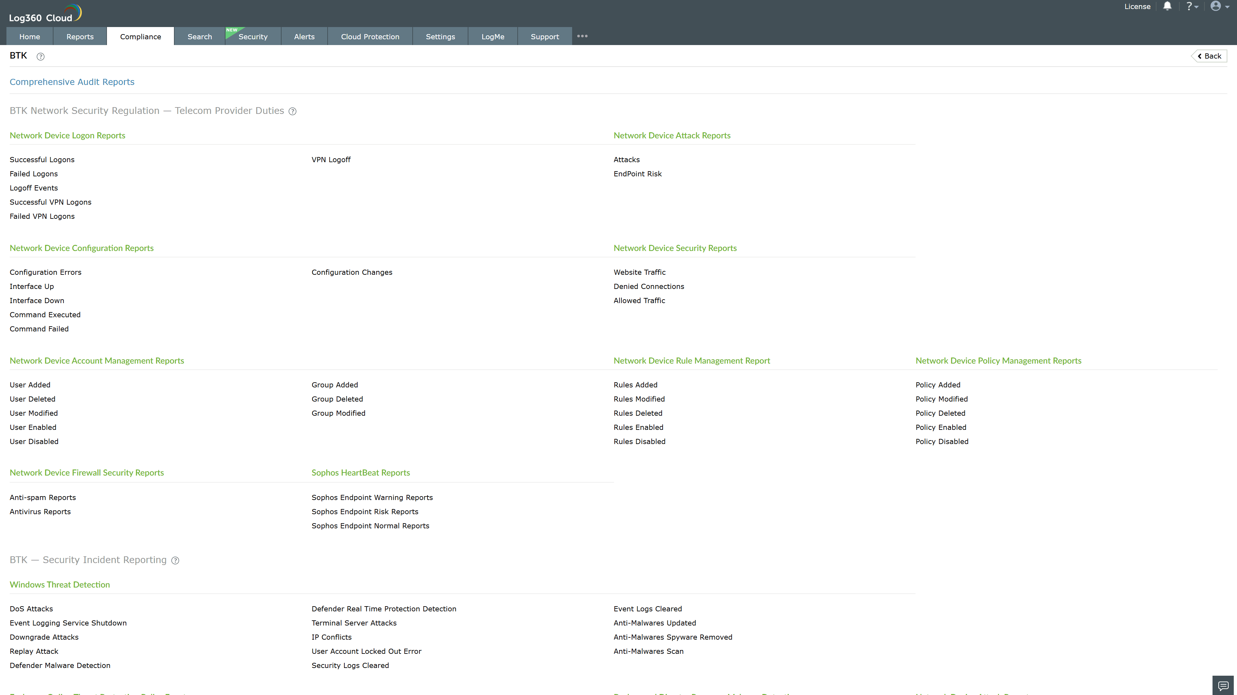
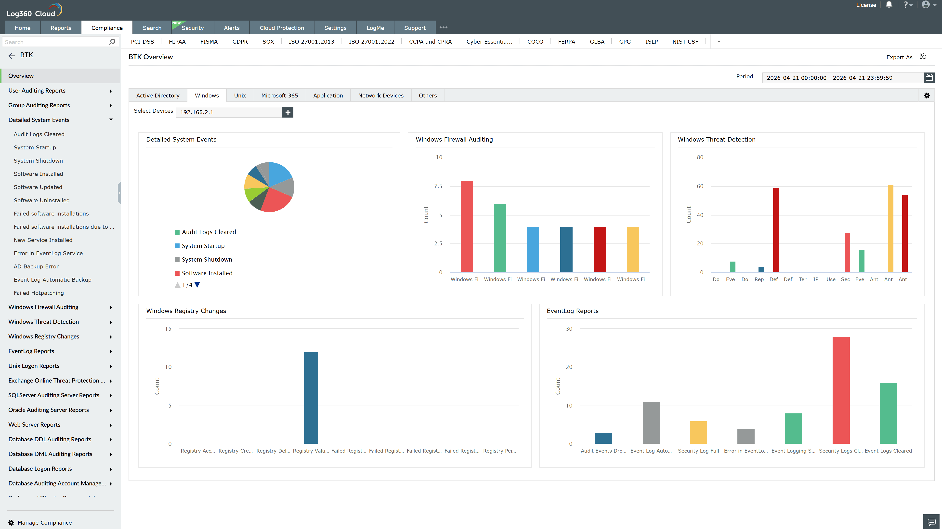
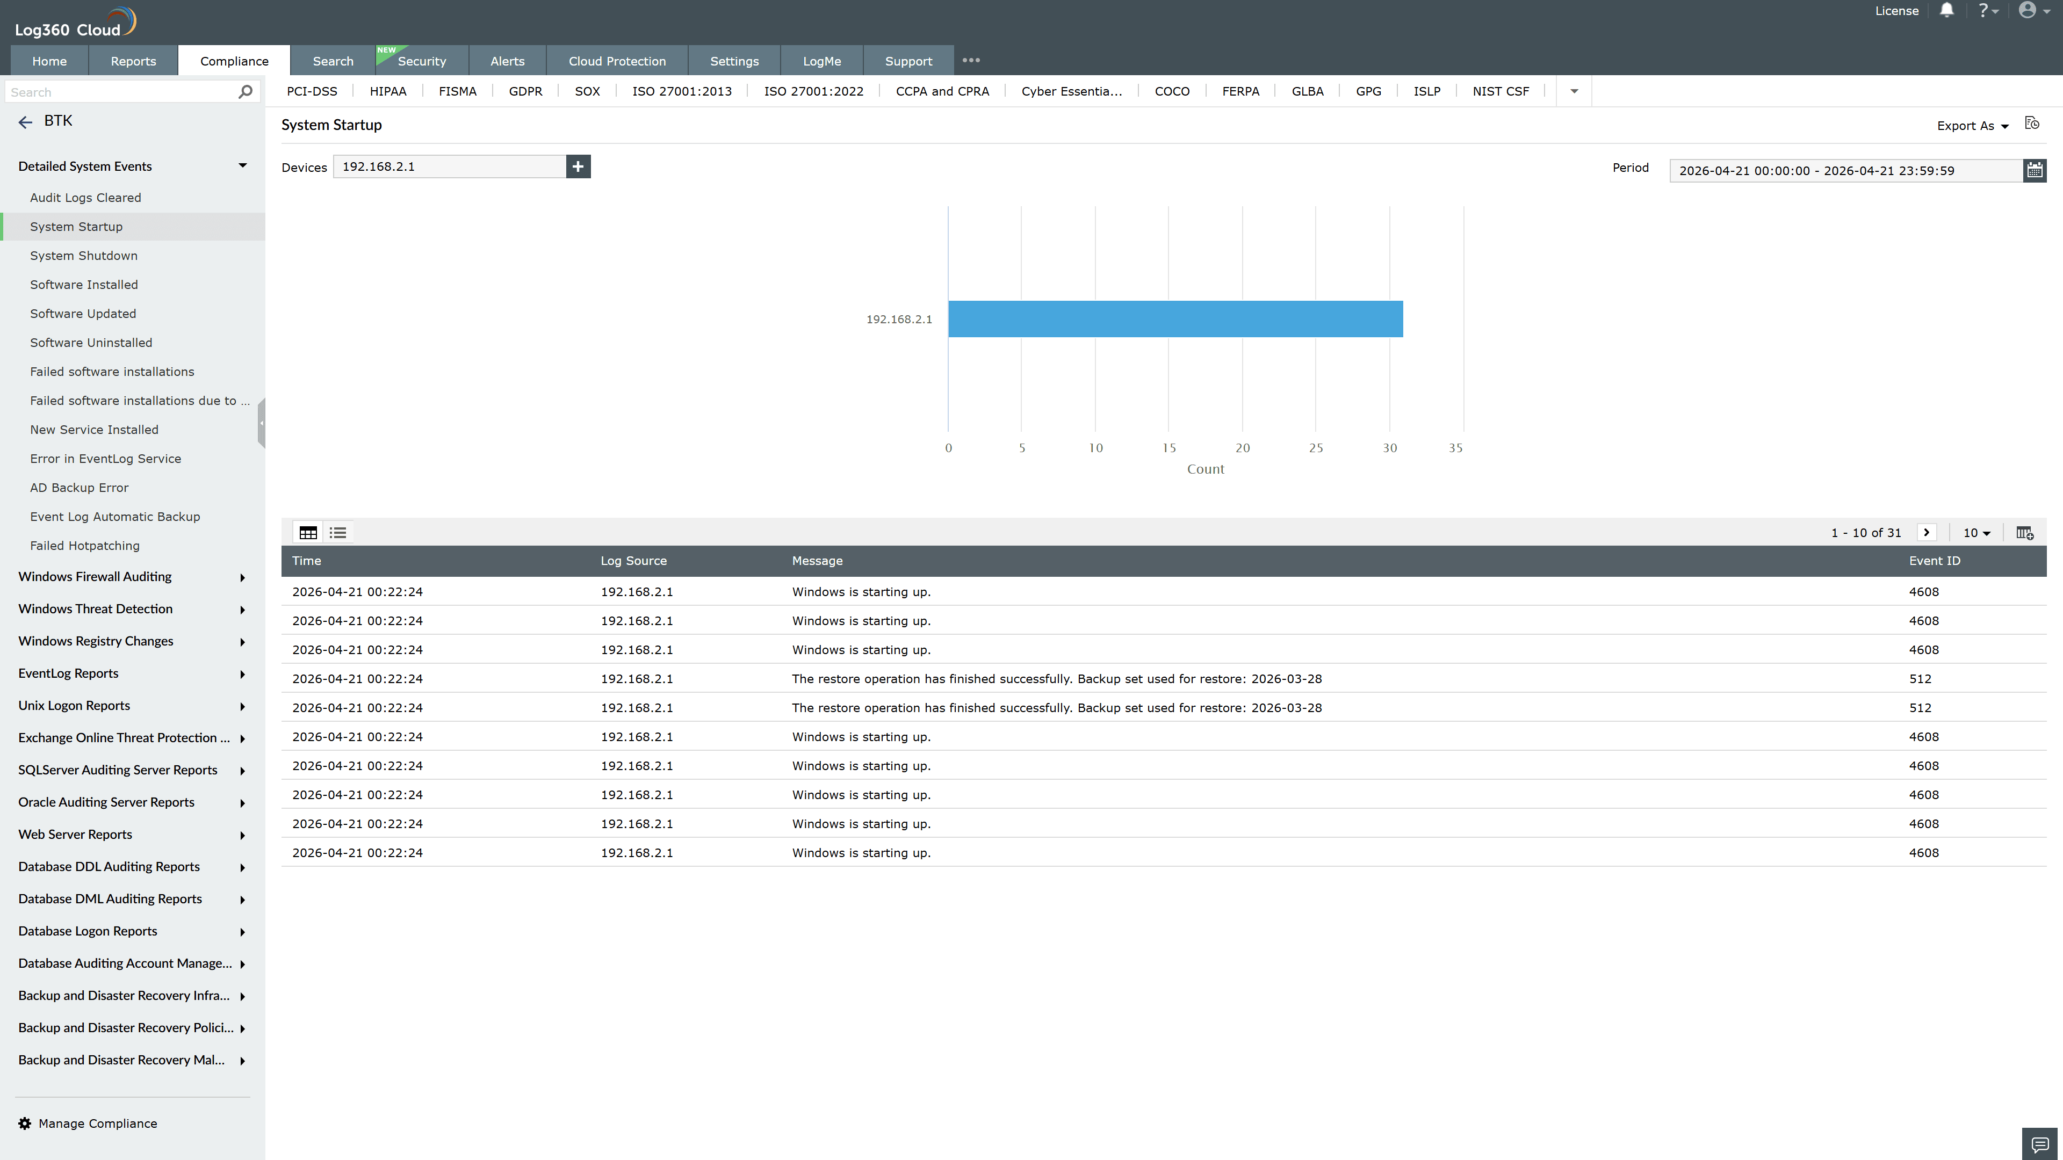
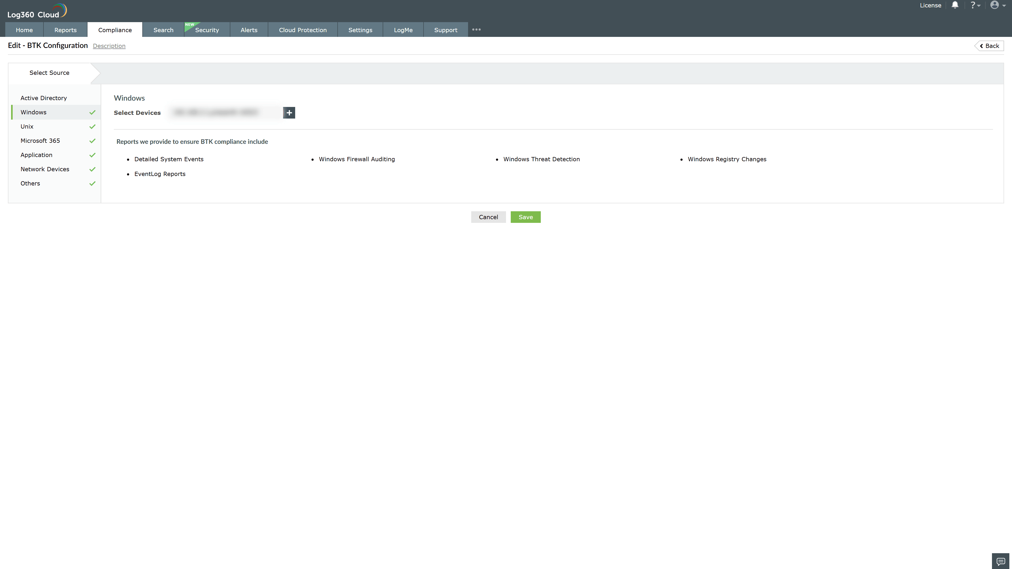

Valid Submission : Yes
Supported Editions : Free, Basic, Standard, Professional, MSSP
Help Document : https://www.manageengine.com/log-management/help/integrations/compliance-extensions.html
Help Video : Not provided
Tags : Log360, Compliance, Privacy monitoring, Data privacy, Regulatory compliance
Supported DCs : US, IN, JP, CA, AU, UK and EU
Privacy Policy:
Terms of Service:
Release Notes:
Predefined reports for the BTK Telecommunications Security Regulation Compliance

